|  |
| --- |
| Underwater Video Recording System |
| Dredge Mounted Camera v1.2 |

|  |
| --- |
| Arthur Bondar  *Electronics Technologist*  *July 20, 2020* |

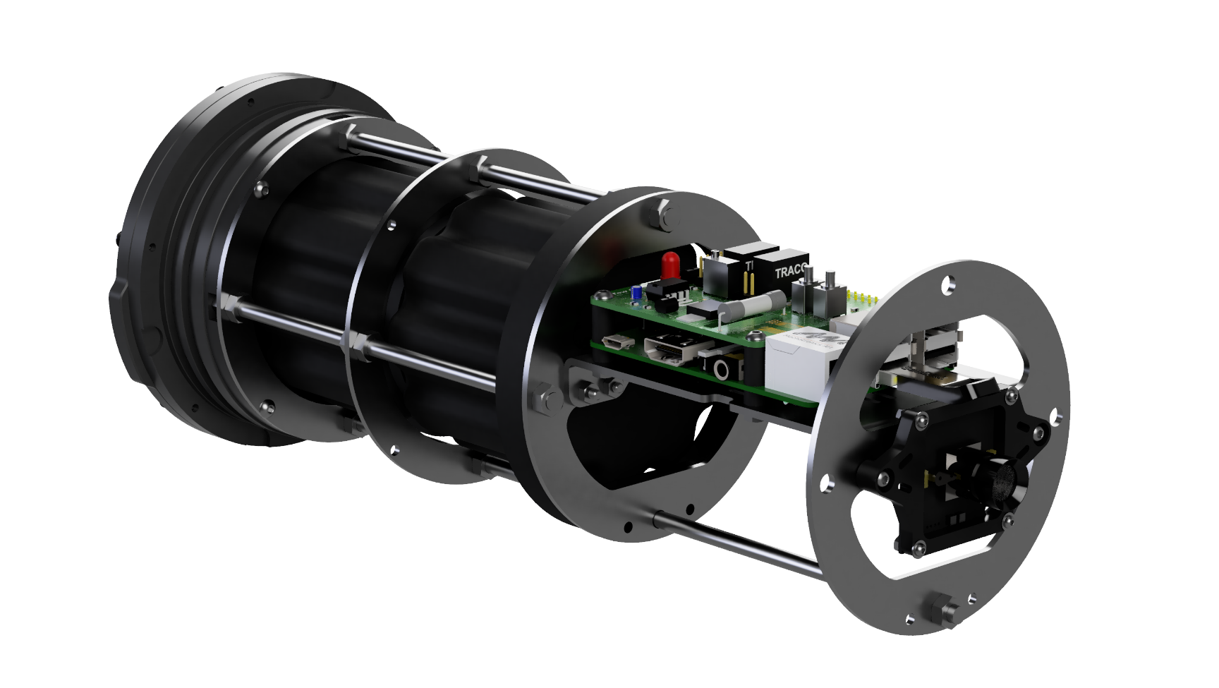

Contents

Overview 2

Aluminum Frame 3

Camera Settings 4

Video Output 5

Storage Requirements 5

Run Time 5

# Overview

Dredge Mounted Camera v1.2 is an upgraded unit developed to aid scallop fisheries with industry research and regulation. The frame upgraded with sturdy aluminum sheet metal parts, and the recording module uses a USB low light camera that offers audio and native video encoding.

Specifications

|  |  |
| --- | --- |
| Video | HD usb low light camera 2.1MP  (1920x1080p @30fps) |
| Run Time | 100hr – 4 days |
| Dept Rating | Acrylic Housing – 100m (328ft)  Aluminum Housing – 400m (1312ft) |
| Memory | 256GB USB3.0 flash drive |
| Battery Pack | 266Wh 14.8V 18Ah Lithium-ion |
| Charger | 20A,10A Fast/Balance charging  1-2hr charge time |
| Dimension | Housing O.D. – 114.3mm (4.5”)  Length – 340mm (13.4”) |
| Weight | Acrylic Assembly – 6.4 lb (2.9 kg)  Aluminum Assembly – 6.8 lb (3.1 kg) |

# Aluminum Frame

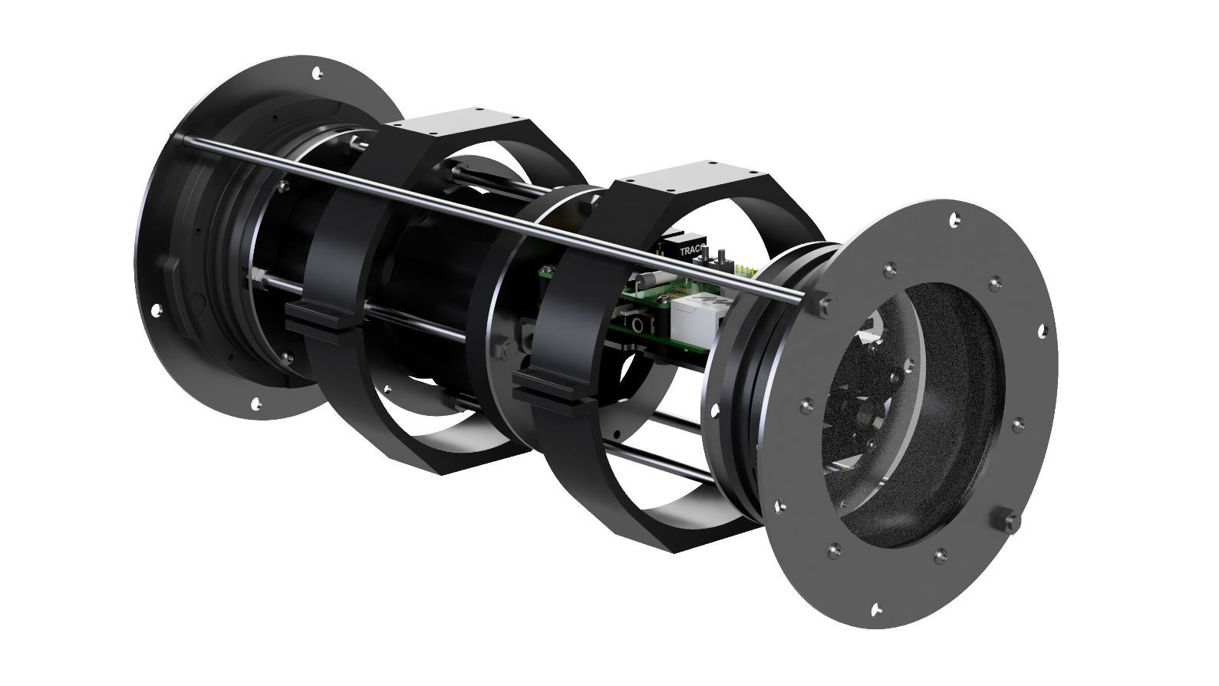The unit uses aluminum parts for the frame and the clamp to increase the rigidity during underwater collisions or dredge vibrations.

The frame held together using M5 threaded rods and nuts. The assembly includes powder-coated sheet metal parts, as well as 3D-printed plastic parts for the flange spacer, battery support and camera mount. The camera module itself is pressed against the aluminum to dissipate the heat generated by the module.

The outer clamp simplified by using 2 aluminum rings that attach directly to the front and back flanges. Two M5 threaded rods and nuts used to press and hold the flange circles.

# Camera Settings

Parameters can be added or removed from the setup file if necessary. In the absence of a value, the unit will use a default option. The format of the setup file has been simplifier and divided into 3 sections:

* [video] –video-specific parameters, such as output format, resolutions, sections length, etc.
* [system] –system parameters such as date-time, log interval, etc.
* [camera] –camera-specific settings such as brightness, contrast, gamma, etc.

To change camera parameters, such as brightness or contrast, connect the camera to a PC via the USB cable and start a media player. Next, tune the video quality by using the settings until the output looks satisfactory. Copy the quality parameters and save them to the setup.txt file.

|  |  |  |
| --- | --- | --- |
| **Parameter** | **Value** | **Description** |
| **[video]** | | |
| section length | 0 – inf (in minutes) | This parameter specifies the video section length in minutes. (default 60). |
| resolution | [width]x[length] | Camera module provides various resolution settings. |
| **[system]** | | |
| set date-time | DD-MM-YYYY **T** HH:MM:SS | Set time manually before each deployment. Allow 1min for the system to boot. |
| led interval | 0 – inf (in seconds) | Interval for the blinking red recording light (0 – off) |
| **[camera]** | | |
| brightness | -64 to 64 | Default 0 |
| contrast | 0 to 64 | Default 32 |
| saturation | 0 to 128 | Default 64 |
| hue | -40 to 40 | Default 0 |
| gamma | 72 to 500 | Default 100 |
| gain | 0 to 100 | Default 0 |
| power_line_frequency | 0 to 2 | Default 1 |
| white_balance_temperature | 2800 to 6500 | Default 4600 |
| sharpness | 0 to 6 | Default 3 |
| backlight_compensation | 0 to 2 | Default 1 |
| exposure_auto | 0 to 3 | Default 3 |
| exposure_absolute | 1 to 5000 | Default 156 |

# Video Output

The USB camera includes a microphone and an onboard video encoder, which streams the H.264 video format directly to the Raspberry Pi. The Pi’s function is to merge the audio and video stream into a playable container such as MP4, MKV or AVI. The MKV container is most desirable as it allows for the stream to be interrupted without corrupting the recording file. MKV is playable to most media players and is interchangeable with MP4.

The camera’s video stream does not have a timestamp built-in. Recording start time indicated in the name of the video file:

[index]_[date]_[time]  
XXX_YYYY-MM-DD_HH-MM.mkv

# Storage Requirements

The video stream compressed by comparing the difference between each frame. Motion and sunlight captured by the lens will result in a larger video file, hence, It is difficult to predict the video size without field tests. The user is encouraged to monitor the file sizes during various deployment conditions.

The maximum file usage can be estimated using a maximum video bitrate of 10k Bps (1.25MBps). The 256GB storage device will be sufficient for 58 hours. The files will be smaller in practice, one 256GB USB drive will be sufficient. The following formula used to calculate the number of hours under the maximum limit:

# Run Time

The power consumption varies depending on the video load and the USB power requirements. The typical average power consumption is 3W. Using the battery capacity of 266Wh, the run time can be estimated as follows:

|  |  |  |
| --- | --- | --- |
| Typical power consumption | 3W | 266Wh/3W = 106.4 hr |
| Low load power consumption | 2.5W | 266/2.5W = 133 hr |
| High load power consumption | 3.5W | 266/3.5W = 88.6 hr |